Internship Project Report
I. Project Overview
1. Project Title
Mutual Fund Purchase Optimizer
2. Problem Statement
Retail investors and financial advisors frequently struggle to optimize fixed-capital allocations across a saturated mutual fund market. The selection process is hindered by:
- High Market Dimensionality: The sheer volume of fund schemes makes manual comparison inefficient.
- Non-Linear Risk-Return Trade-offs: Balancing potential yield against volatility requires advanced quantitative analysis.
- Diversification Complexity: Distributing assets to minimize unsystematic risk is difficult without algorithmic assistance.
- Portfolio Over-Concentration: Existing holdings are often ignored when making new purchases, leading to redundant risk exposure.
3. Objectives
Main Objectives
- Intelligent Recommendation Engine: Develop a data-driven system for optimized, diversified fund allocations.
- Quantitative Risk Profiling: Implement a multi-factor scoring model to align recommendations with user risk tolerance.
- Portfolio-Aware Optimization: Ensure new allocations complement existing holdings.
- Composite Scoring (FQS/FRS): Compute Fund Quality Scores and Fund Risk Scores using Alpha, Beta, and Sortino ratios.
- Transparency: Provide explainable logic for all generated recommendations.
Secondary Objectives
- Multi-Role Ecosystem: Support Investor, Advisor, and Admin personas with distinct workflows.
- Granular Security: Implement Role-Based Access Control (RBAC) via JWT.
- High-Performance Backend: Utilize FastAPI for sub-2-second response times and automated Swagger documentation.
- Scalable Architecture: Deploy via Docker for cloud-readiness.
4. Scope and Limitations
In Scope
- Mutual Fund Recommendation
The system generates optimized mutual fund purchase allocations based on user inputs such as investment amount, duration, and risk preference. It ensures efficient capital distribution across selected funds.
- Portfolio-Aware Allocation
The system analyzes the investor’s existing portfolio to avoid over-concentration in specific funds or categories, ensuring balanced and diversified investment allocation.
- Risk Profiling Engine
A quantitative multi-factor risk scoring model is implemented, considering parameters like age, income, investment duration, stated risk preference, and historical investment behavior to determine the user’s risk tolerance.
- Fund Scoring & Evaluation
Mutual funds are evaluated using industry-standard financial metrics such as CAGR, Volatility, Sortino Ratio, Beta, and Alpha. These metrics are further used to compute composite scores like Fund Quality Score (FQS) and Fund Risk Score (FRS) for ranking and selection.
- Explanation Generation
The system provides human-readable explanations for each recommendation, clearly describing why a particular fund is selected, how it aligns with the user’s risk profile, and how allocation decisions are made.
- Multi-Role Access (RBAC)
Supports multiple user roles including Investor, Advisor, and Admin, with secure Role-Based Access Control (RBAC) using JWT authentication.
- Admin Fund Management
Admin users can add, update, or remove mutual fund data and associated financial metrics, ensuring that the system remains updated and configurable.
- API + UI Interface
The system provides a RESTful API using FastAPI for backend services and a user-friendly interface built with React for seamless user interaction.
- Cloud Deployment
The application is containerized using Docker and designed for deployment on cloud platforms such as AWS, ensuring scalability, availability, and performance.

Out of Scope / Limitations
- No Real-Time Market Data Integration
The system relies on historical NAV data and precomputed metrics. It does not fetch or process real-time market updates.
- No Trade Execution or Payment Processing
The platform does not execute actual mutual fund transactions. It only provides advisory recommendations and does not handle payments.
- No Machine Learning or Predictive Modeling
The recommendation engine is rule-based and score-driven, without the use of machine learning or AI-based predictive techniques.
- No Guaranteed Returns
The recommendations are based on historical data and predefined logic; therefore, they do not guarantee future investment returns and should not be treated as financial advice.
5. Research Method
The project follows a structured and analytical methodology that integrates SDLC (Software Development Life Cycle) with financial modeling and optimization techniques to develop a robust mutual fund recommendation system. The methodology is detailed as follows:

1. Software Development Life Cycle (SDLC) Approach
- Requirement Analysis
  - Studied the mutual fund domain, investment workflows, and advisor requirements
  - Identified key stakeholders: Investor, Advisor, and Admin
  - Defined problem scope, constraints, and success criteria
  - Gathered functional (FRS) and non-functional (NFR) requirements
- Design Phase
  - Designed system architecture using High-Level Design (HLD) and Low-Level Design (LLD)
  - Created data models, ER diagrams, and database schema
  - Defined API contracts and workflows (sequence diagrams)
  - Planned modular and scalable system components
- Build (Development Phase)
  - Developed backend using FastAPI and frontend using React
  - Implemented core modules: authentication, portfolio management, recommendation engine
  - Integrated APIs and UI components for end-to-end functionality
  - Followed modular and clean code practices

- Testing Phase
  - Performed manual testing for UI, validation, and workflows
  - Conducted API testing using Postman for all endpoints
  - Implemented automation testing using Selenium and Pytest
  - Validated functionality, security, and system stability
- Deployment Phase
  - Containerized the application using Docker
  - Deployed system on AWS cloud infrastructure
  - Configured environment variables, logging, and monitoring
- Release Phase
  - Finalized system for production use
  - Prepared complete documentation (HLD, LLD, API docs, Test reports)
  - Ensured system validation and user readiness
Testing Objectives and Operational Scope
To manage stakeholder expectations and optimize resource allocation, it was essential to define clear boundaries between UI-level validation and backend technical functionality. This distinction ensures that testing efforts were concentrated on user-facing logic and workflow accuracy.
Testing Boundaries: In-Scope vs. Out-of-Scope
In-Scope | Out-of-Scope
Login & Signup Modules (User/Advisor) | Backend Authentication Logic
Role-Based Access Control (RBAC) UI Flows | Database Validation & Storage
Front-end Input Field Validation | API Testing & Integration
Navigation and Error Message Display | Performance, Load, & Server-side Security
The core objectives of this cycle focused on the precise validation of User, Advisor, and Admin roles. These were analyzed through the following strategic lenses:
- Role-Based Redirection: Ensures users are funneled to appropriate dashboards based on their credentials, preventing unauthorized access to specialized advisor tools or administrative functions.
- Registration Integrity: Verifies that both standard users and financial advisors can complete their respective registration processes without navigational dead-ends.
- Input Logic Enforcement: Confirms that the UI correctly identifies valid and invalid data, maintaining data hygiene before information reaches the server.

II. Methodology
1. Testing Methods
The Test Approach followed a disciplined, multi-step execution process to ensure consistency across all the test cases:
- Execute: Initiate the specific user flow manually within the Figma prototype.
- Enter Data: Input test data as specified in the master Test Case documentation.
- Observe: Monitor the system's response, navigation, and visual feedback.
- Compare: Evaluate the actual result against the predefined Expected Result.
- Mark: Formally record the case as PASS or FAIL.
Frontend testing is being conducted to validate the correctness, usability, responsiveness, and functional behavior of the application interface across all user roles. The testing focused on ensuring that all user interactions, workflows, and UI elements perform as expected for different user roles — Investor, Advisor, and Admin.
The testing approach combined manual testing for UI/UX validation and automation testing for repeatability and regression coverage, ensuring comprehensive validation of the frontend layer.
- Frontend Manual Testing
Focused on UI validation, user interaction flows, boundary value analysis, and end-to-end workflow testing.
- Automation Testing
Implemented using Selenium and Pytest to validate logic, security, and regression stability across multiple modules.
The testing ensures that:
- UI components render correctly
- User workflows execute without errors
- Input validations are enforced
- System responds correctly across devices

Frontend Manual Testing
Frontend manual testing was conducted to evaluate UI correctness, functional behavior, form validation, navigation, and responsiveness across all three user roles. Testing was executed using predefined test cases documented in Excel, with Chrome DevTools used for responsive layout inspection.
A total of 250 test cases were executed across 7 test modules, covering all major application components.

3.7.2.1 Test Environment
Component | Details
Application Type | Web Application
Environment | Localhost
Browser | Google Chrome
Testing Type | Manual Testing
Tools Used | Excel, Chrome DevTools

3.7.2.2 Test Scope
In Scope:
- UI Validation Testing
- Functional Testing
- Form Validation Testing
- Navigation Testing
- Dashboard and module-level testing

3.7.2.3 Entry and Exit Criteria
Entry Criteria:
- Application deployed on localhost
- All modules accessible
- Test cases created and reviewed
- Test environment configured
Exit Criteria:
- All test cases executed
- Defects identified and documented
- Critical issues analyzed
- Test report prepared
2. Tools and Technologies
Tool | Purpose
Excel | Test case design and execution tracking
Chrome DevTools | UI inspection and responsiveness testing
Selenium | UI automation
Pytest | Test execution and reporting
Chrome browser | Test execution

3. Process Flow
Entry Criteria:
- Stable build deployed on localhost
- Test cases reviewed and approved
- All RBAC modules accessible
Exit Criteria:
- 100% test execution achieved
- All defects documented
- Pass rate exceeded 90%
4. Test Environment
Component | Details
Application Type | Web Application
Environment | Localhost
Browser | Google Chrome (Latest Version)
Testing Scope | Manual (Functional/UI) & Automation (Logic/Security)
3.7.3 QA Testing Workflow
The frontend testing process followed a structured and iterative Quality Assurance workflow:

3.7.3.1 Requirement Understanding
The initial phase involved analyzing the application requirements and understanding system behavior across all user roles — Investor, Advisor, and Admin.
- Studied user workflows such as:
  - User registration (Signup)
  - Authentication (Login)
  - Dashboard navigation
  - Investment workflow
- Identified expected outcomes and system constraints
- Considered edge cases such as:
  - Invalid inputs
  - Unauthorized access attempts
  - Boundary values

3.7.3.2 Test Case Design
Test cases were systematically designed to ensure maximum functional and UI coverage.
- Total Test Cases Designed: 250+
- Categorization:
  - Positive scenarios (valid inputs)
  - Negative scenarios (invalid inputs)
  - Edge cases (boundary conditions)
  - UI validation cases
  - Security validation cases
Each test case included:
- Scenario ID
- Scenario description
- Test Case ID
- Steps to execute
- Expected result
- Actual result
- Status (Pass/Fail)
- Priority
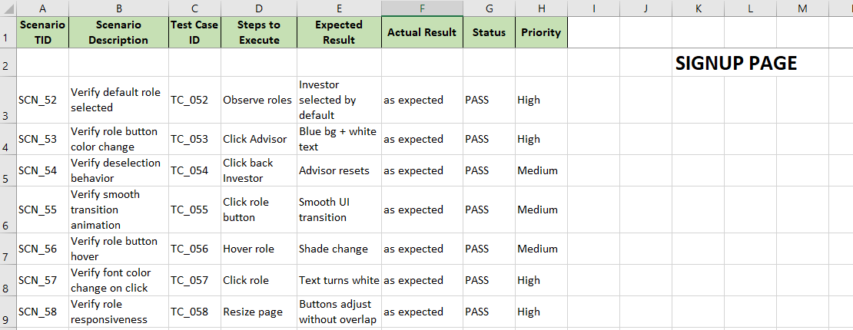
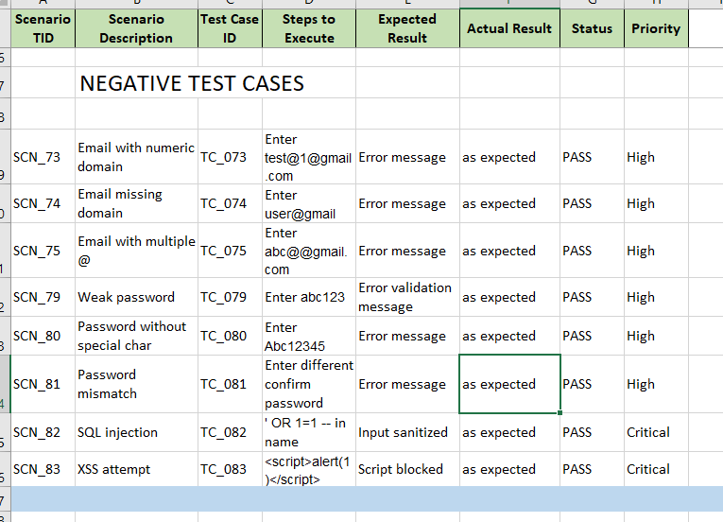

3.7.3.3 Test Environment Setup
A controlled test environment was established to ensure consistent execution.
- Application deployed on localhost
- Browser used: Google Chrome
- Verified:
  - API connectivity
  - UI rendering
  - Seamless navigation between modules

3.7.3.4 Test Execution
All test cases were executed manually following a systematic approach.
- Execution Type: Manual Testing
- Results logged as:
  - Pass
  - Fail
  - Pending
Validation areas:
- UI behavior
- Functional workflows
- Input validation
- Navigation
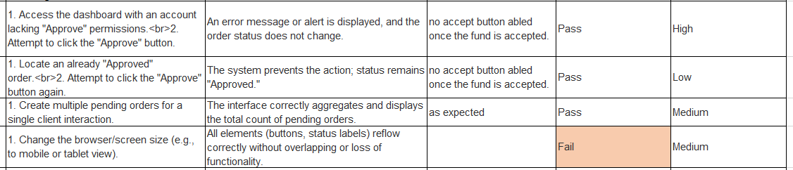

3.7.3.5 Defect Identification
Defects were identified during execution and categorized based on impact.
Types of defects found:
- UI responsiveness issues
- UI locator issues
- Timeout exception or session handling issues
3.7.3.6 Defect Reporting in Jira
- Documented defects with:
  - Bug ID
  - Module
  - Description
  - Steps to reproduce
  - Expected vs Actual results
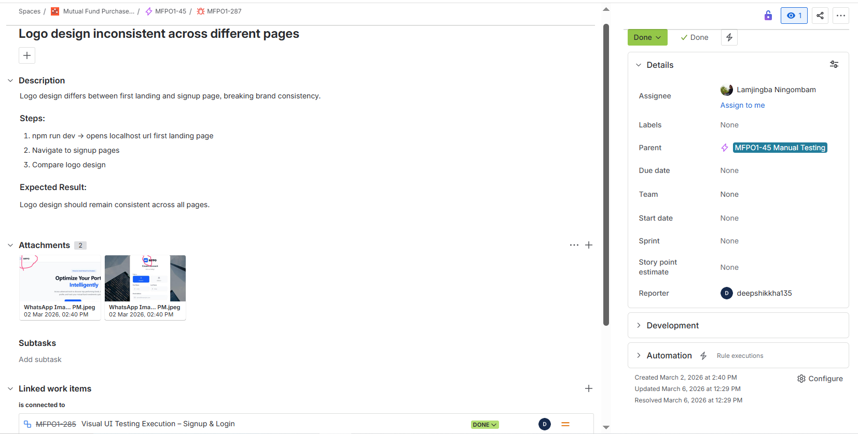
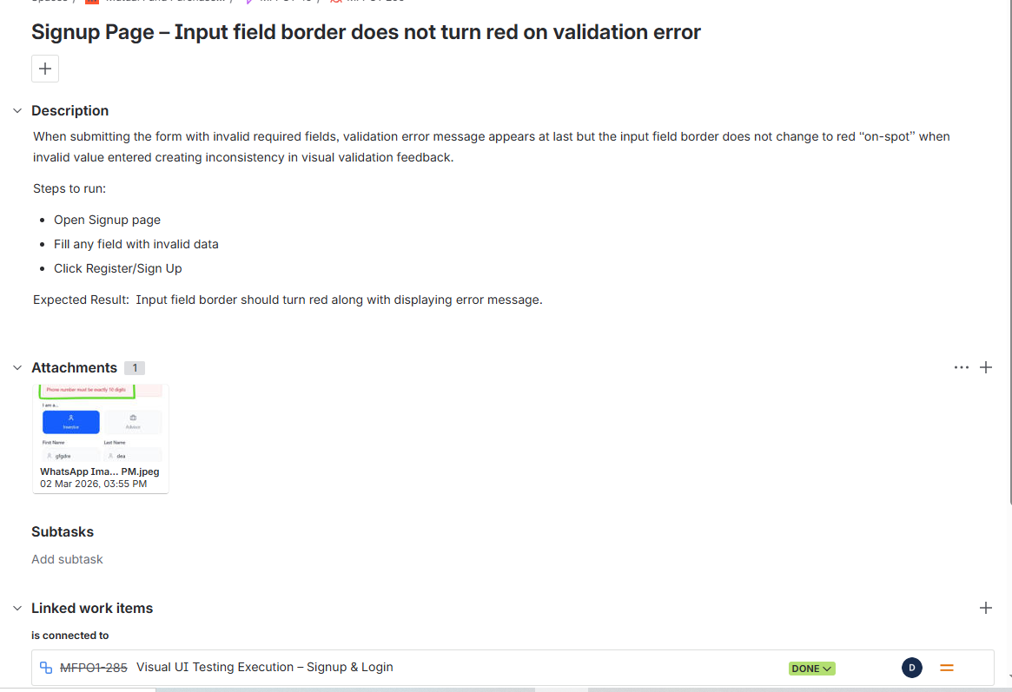
3.7.3.7 Retesting and Validation
- Re-tested all fixed issues
- Verified expected behaviour
- Ensured no regression issues
III. Analysis & Findings
1. Manual Testing Strategy & Interpretation
The manual testing phase was designed to evaluate the "human" element of the system. The core authentication and the Investment Flow proved to be robust.
- Module Status: High stability was observed in the Investor, Advisor and Admin dashboards.
- Validation Findings: Most manual failures were localized to the presentation layer, specifically lack of Blur Validation and inconsistent string formatting.
2. Automation Testing & Logic Verification
Automated execution focused heavily on the mathematical integrity of the recommendation engine.
- Logic Module Testing: 30 dedicated test cases validated the computation of Alpha, Beta, and Sortino Ratios used for the Fund Quality Score (FQS). Results indicate high precision in backend financial calculations.
- Security & RBAC: 30 test cases verified JWT token persistence and role restriction; only 1 failure was recorded, confirming high system security.
- Failure Clusters: Automation identified specific clusters of failures in Signup (2 failures) and Dashboard Miscellaneous (9 failures). The latter was primarily due to edge cases in data fetching during rapid navigation.
3. Insights on System Maturity
The system has moved from an unstable state (82% pass rate on March 17) to a UAT-ready state (94.8% pass rate on March 18). The core logic—the engine that calculates allocations—is stable. Current remaining issues are predominantly related to frontend input sanitization. The increase in pass percentage from 82% to 94% demonstrates effective defect resolution and rapid feedback integration between testing and development cycles.

3.7.7 Defect Management Process
The defect management process followed a structured lifecycle:
- Defect identification during test execution
- Screenshot capture for evidence
- Documentation including:
  - Steps to reproduce
  - Expected vs actual result
- Severity classification (High, Medium, Low)
- Reporting to development team
- Tracking defect status (Open → Fixed → Retested → Closed)

3.7.6 Module-wise Test Coverage and Analysis
To ensure comprehensive validation, testing was performed module-wise, covering UI, functionality, validation logic, and responsiveness across all components.
IV. Results & Outcomes
1. Manual Testing
The following table demonstrates the remediation velocity between reporting cycles:
Date | Total Cases | Passed | Failed | Pending | Pass %
17th March | 250 | 205 | 31 | 14 | 82.0%
18th March | 250 | 237 | 13 | 0 | 94.8%
23rd March | 253 | 252 | 1 | 0 | 99.6%
2. Automation Testing
Category | Total Cases | Passed | Failed | Pass %
Signup | 64 | 62 | 2 | 96.8%
Signin | 21 | 21 | 0 | 100%
Dashboard (Positive/Negative/Security/Logic) | 120 | 113 | 7 | 94.1%
Dashboard (Misc) | 30 | 21 | 9 | 70.0%
Total Automation | 235 | 217 | 18 | 92.3%
3. Efficiency Metrics
- Execution Coverage: 100% (All planned cases executed).
- Defect Density: 7.6 % (18 defects), primarily concentrated in the UI validation layer.
Several types of testing were performed, each contributing to the overall integrity of the module:
- Functional Testing: Confirmed that buttons, links, and forms perform their intended actions.
- Negative Testing: Verified that the system gracefully handles incorrect inputs via explicit Error Message Displays, ensuring total alignment with the requirement for clear user-facing feedback and preventing user frustration.
- Boundary & Validation Testing: Checked the limits of input fields (e.g., character counts) to ensure data conforms to expected formats.
- UI-Level Security Testing: Ensured that password fields are masked and sensitive role-based paths are not accessible to unauthorized roles within the prototype logic.
Robust input validation and Role-Based Access Control (RBAC) are the dual pillars of the MFPO’s security and usability strategy at the UI level. By enforcing strict rules at the point of entry, the system ensures a high-quality user experience and data integrity.
Key Input Validation Results:
- Email & Password Validation: Ensures formats are correct and passwords match during the confirmation phase to prevent account creation errors.
- ARN Validation: Acts as a critical regulatory gatekeeper, ensuring the MFPO maintains compliance with financial intermediary standards by verifying that only credentialed Advisors can register for specialized access.
- Phone Number & Required Fields: Mandatory data points are strictly enforced, preventing the submission of incomplete profiles and maintaining professional data hygiene.
The RBAC mechanism was successfully validated across User, Advisor, and Admin roles. The system correctly differentiated between these roles to trigger appropriate dashboard redirections. This is vital for the multi-tenant nature of the MFPO, ensuring Advisors see portfolio management tools while standard Users access purchase optimization features. While these UI behaviors are currently validated, they represent the essential transition point toward backend development.

3.7.5 Coverage Metrics
The testing achieved 100% execution coverage, ensuring that all planned test scenarios were validated at least once, with approximately 90% functional coverage across implemented modules.
Unit Testing Validation
The primary objective of this testing phase was to verify the functional integrity of individual frontend components and ensure that critical user flows—such as authentication, dashboard rendering, and utility components—operate correctly in isolation.
2. Scope of Testing
The testing scope encompassed the following areas of the frontend application:
- Authentication Flow: Login via OTP, OTP Verification, Sign-in, Signup, and Password Reset/Forgot Password.
- User Dashboards: Admin, Advisor, and Client (Investor) dashboards.
- UI & Utilities: Toast notifications, Loading Spinner, Error Boundary, Risk Profile Modal, and Portfolio view.
- Navigation: Home page and 404 Not Found handling.
3. Test Environment
- Framework: Vitest v4.0.18.
- Library: React Testing Library (indicated by TestingLibraryElementError).
- DOM Simulation: JSDOM.
- Project Path: E:/FE_BE_GIT/FRONTEND_GIT.
- Execution Time: 74.44 seconds.
4. Test Execution Summary
Metric | Count
Total Test Files - | 17
Passed Test Files - | 15
Failed Test Files - | 2
Total Test Cases - | 28
Passed Test Cases - | 26
Failed Test Cases - | 2

The frontend test suite, executed using Vitest v4.0.18, completed with a 92.8% pass rate. Out of 17 test files, 15 passed and 2 failed, resulting in 26 passing tests and 2 failures.
1. Execution Summary
- Total Tests: 28
- Passed: 26
- Failed: 2
- Duration: 74.44 seconds
2. Failed Test Details
Test File | Test Case | Error Type | Root Cause
src/tests/ClientDashboard.test.jsx | renders investor header and default investment tab | TestingLibraryElementError & ReferenceError | The test could not find the text "Investor Dashboard". A stderr log reveals a ReferenceError: historyRes is not defined at line 512 in ClientDashboard.jsx.
src/tests/Signup.test.jsx | handles mismatched passwords | TestingLibraryElementError | The test failed to find an input field with the placeholder text +91 98765 43210.
3. Key Successes
The following modules passed all unit tests successfully:
- Authentication Flow: Login OTP, OTP Verification, Sign-in, and Password Reset/Forgot Password.
- Dashboards: Advisor Dashboard and Admin Dashboard.
- UI Components: Toast notifications, Loading Spinner, Risk Profile Modal, and Error Boundary.
- General Navigation: Home page and Not Found (404) page.
4. Technical Observations
- Code Bug in Dashboard: The failure in ClientDashboard.test.jsx appears to be a genuine application bug rather than a test issue, as the component throws a ReferenceError during the fetchPortfolio execution.
- Signup Placeholder Mismatch: The failure in Signup.test.jsx suggests that the phone number input's placeholder might have changed or is not rendering as expected when the test attempts to interact with it
V. Challenges Faced
1. Severity Categorization
Defects identified during the final cycle were categorized to prioritize developer remediation:
Defect Description | Severity | Type
Negative Value Entry: System allowed investment amounts < 0. | High | Functional / Logic
Duration Fetching Error: Incorrect time-horizon data retrieved for FRS. | High | Functional / Data
Special Character Validation: Improper sanitization in profile fields. | Medium | Security / Validation
Blur Validation: Fields only validate on submit, not on focus-loss. | Medium | UI/UX
Capitalization Consistency: First-word capitalization missing in UI. | Low | UI/Visual
2. Operational Challenges
- Asynchronous Development: Testing the Advisor/Investor modules while the Admin Dashboard was still "Under Development" required the use of mock data to simulate administrative configurations.
- Edge Case Logic: Verifying "Duration Fetching" proved difficult due to the variety of date formats in the historical NAV datasets.
3. Resolution Strategy
All High-Severity bugs were raised first in Jira. I worked closely with the development team to ensure that the logic errors regarding negative values and duration were prioritized for the next sprint, effectively moving the system toward 100% stability.

VI. Learnings & Skills Gained
1. Technical & Functional Skills
- QA Workflow: Mastered the full testing lifecycle from Test Plan creation to Regression Testing and Final Report generation.
- Logic Verification: Deepened expertise in verifying financial algorithms (Alpha, Beta, Sortino) within a FastAPI/React environment.
- Security Testing: Executed RBAC and JWT validation to ensure data privacy across Investor and Advisor roles.
2. Industry Exposure
- Quantitative Finance: Developed a professional understanding of risk-aligned mutual fund recommendations and the importance of portfolio diversification.
- Regulatory Logic: Gained insight into how rule-based systems provide the "Explanation Generation" necessary for financial advisory transparency.
3. Soft Skills & Stakeholder Communication
- Bug Reporting: Refined the ability to communicate complex technical failures to developers using clear, severity-ranked documentation.
- Strategic Reporting: Learned to present data-driven insights (e.g., pass-rate trends) to management to inform release readiness decisions.

3.7.8 Role and Contribution
During the internship, I was responsible for end-to-end frontend Quality Assurance activities, contributing to both manual and automated testing processes.

Key Contributions
- Designed and executed 250+ manual test cases
- Performed:
  - UI Testing
  - Functional Testing
  - Validation Testing
- Identified multiple defects across all modules
- Conducted end-to-end workflow validation
- Verified role-based access control (RBAC)
- Performed negative and edge case testing
- Validated:
  - Data consistency
  - UI alignment
  - Workflow correctness
- Documented defects with screenshots and detailed reports
- Collaborated with developers for:
  - Bug fixing
  - Retesting
- Executed automation test suite (235 test cases)

3.7.9 Test Case Design Strategy
Test cases were designed using established software testing techniques:

Equivalence Partitioning
- Inputs divided into valid and invalid groups
- Example: Valid email vs invalid email formats

Boundary Value Analysis
- Tested extreme input limits
- Example:
  - Minimum password length
  - Maximum character limits

Positive Testing
- Verified correct behavior with valid inputs

Negative Testing
- Ensured system handles invalid inputs gracefully

Edge Case Testing
- Extremely long inputs
- Empty fields
- Special characters

Security Testing
- SQL Injection attempts
- XSS input validation

3.7.10 DEFECT MANAGEMENT PROCESS
The defect lifecycle followed a structured tracking approach:
- Defect identified during testing
- Screenshot captured
- Defect logged with details
- Severity assigned:
  - High (critical functionality)
  - Medium (validation/UI issues)
  - Low (minor UI issues)
- Shared with development team
- Status tracked:
  - Open → In Progress → Fixed → Retested → Closed
3.7.11 Defect Evidence
- so

